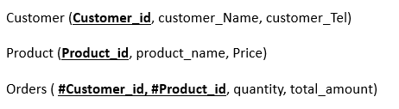
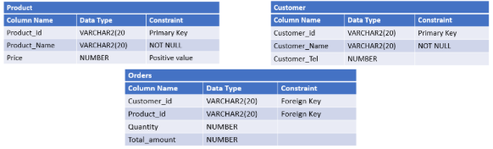
- / create the above given relational model using SQL language and based on the different mentioned constraints:

CREATE TABLE Customer (
Customer_ID VARCHAR(20),
Customer_Name VARCHAR(20) NOT NULL,
Customer_tel INT,
PRIMARY KEY (Customer_ID)
);
CREATE TABLE Product (
Product_ID VARCHAR(20),
Product_Name VARCHAR(20) NOT NULL,
Price INT UNSIGNED,
PRIMARY KEY (Product_ID)
);

CREATE TABLE Orders (
Customer_ID VARCHAR(20),
Product_ID VARCHAR(20),
Quantity INT,
Total_amount INT,
FOREIGN KEY (Customer_ID) REFERENCES Customer(Customer_ID),
FOREIGN KEY (Product_ID) REFERENCES Product(Product_ID)
);
2 / After creating tables, write SQL commands to:
- Add a column Category (VARCHAR2(20)) to the PRODUCT table.
- Add a column OrderDate (DATE) to the ORDERS table which have SYSDATE as a default value.

ALTER TABLE Product
ADD Category VARCHAR(20);

ALTER TABLE Orders
ADD OrderDate DATE DEFAULT SYSDATE();

